Template for English Abstract
(Times New Roman size14 , bold)

First Author Times New Roman 11 pt bold (centered)¹, Second Author Times New Roman 11 pt bold (centered)² , ….

1-Affiliation, info@allhamayesh.ir Times New Roman 11 pt
2-Affiliation, info@allhamayesh.ir Times New Roman 11 pt
……

Abstract
The abstract appears before the keywords. Abstract must be about 200 words. However, it must be limited between 150 to 200 words. The abstract should clearly state, the objective, results and the conclusion of the work.

Keywords: maximum of eight keywords seperated by “,”.

Introduction
The paper must not exceed 12 pages. Please use the following guidelines in preparing your full papers. If papers are not prepared according to the following guidelines they will be withdrawn from the conference program.

Elements of a Paper
The basic elements of a paper are listed below in the order in which they should appear:
- Conference header
- Paper title
- Author names and affiliations
- Abstract
- Keywords
- Introduction
- Main body of paper, including figures and tables, page numbers and footer, headings, enumerations, etc.
- Conclusions
- Acknowledgments
- Nomenclature(Not-necessary for two-page summary paper)
- References
- Appendices

Paper Preparation
All papers must be written in either English or Persian (Farsi). Paper will be presented in the language that it is written.
Paper must send by uploading in the conference websit. Don’t use Email for sending papers.
For English papers; the fonts for the different parts of a paper are in Times New Roman as follows:
- Title: 12 pt bold (centered)
- Author(s): 10 pt bold (centered)
- Affiliations: 10 pt (centered, italic)
- Keywords: 10 pt
- Section Headings: 11 pt bold
- Subsection Headings: 10 pt -Others: 10 pt
Each A4 page is prepared in one columns with 10 mm space between the columns and 20 mm margin all-round. The Abstract starts 90mm from the top of the page on the first page.
Papers must be prepared using Word 2003 or higher. They must be submitted in both PDF format and a word file.
The headings will start from the far left.
Use single spacing with no space between the section headings and the paragraph following it. Put one space between the texts of main sections.
Paper must have page numbers.
System of Units
SI system of units is deemed to be used. If necessary use the equivalent value in the other system of units in brackets after the SI system of units.

Equations
Equations start from the far left of the column and numbered consecutively. The equation numbers must be bracketed and placed opposite to the equation on the far right of the line in that column.

(1)

Tables, Figures and Photographs
Tables must be numbered and the title of the table must be placed on the top of the table with the footnotes on the bottom. Tables must appear where (or as close as to) they are first mentioned in the text. They must be referred in the text as "Table 1".
Figures must be numbered and the caption of the figure must come at the bottom of the figure. All the legends and the numerical values on the axes of the curves must be clear and readable. Figures must appear where (or as close as to) they are first mentioned in the text. They must be referred in the text as "Figure 1".
Photographs must original and follow 2 above for numbering and captions.
Leave one space between the Table/Figure and the text following it.

Table 1-major cities on the 21 routes to london
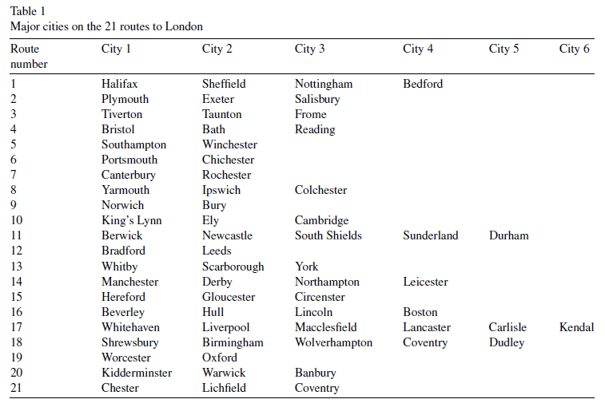

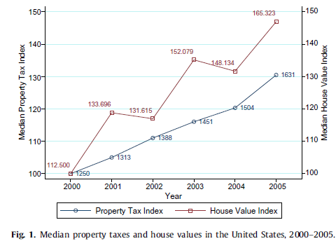
Figure (1) median property taxes and house valuse in the united states, 2000-2005

Results Discussion
All the obtained results should be carefully investigated and compared with the other works. Two page summary papers must include results and discussion sections.

Conclusions
Main conclusions of the paper must be put here.

List of Symbols
The list of symbols comes after the acknowledgment and before references. The English symbols come first followed by the Greek symbols. Both must be typed in alphabetical order and separated.

References
References must be numbered and be listed in the list of references in the order that they are referred to in the text.
Their number must be put in squared bracket, i.e. [1].
The complete details of the references will appear in the list of references.

For journal papers, books and conferences papers use the following formats:
[1] | Assembly Jobs, Economic Development, and the Economy Committee, 2006. 20,Years of California Enterprise Zones: A Review and Prospectus, Sacramento,California, April 12, 2006.
[2] | Timoshenko, S.P. and Woinowsky-Krieger, S., 1959, Theory of Plates and Shells, New York: McGraw-Hill Book Company.
[3] | Billings, Stephen, 2009. Do enterprise zones work? An analysis at the borders.Public Finance Review 37 (1), 68–93.

